**Project Design Phase-II**

**Data Flow Diagram & User Stories**

|  |  |
| --- | --- |
| Date | 06 May 2023 |
| Team ID | NM2023TMID15467 |
| Project Name | Traffic Intelligence: Advanced Traffic Volume Estimation with Machine Learning |

**Data Flow Diagrams:**

A Data Flow Diagram (DFD) is a traditional visual representation of the information flows within a system. A neat and clear DFD can depict the right amount of the system requirement graphically. It shows how data enters and leaves the system, what changes the information, and where data is stored.



**Example:** [**(Simplified)**](https://developer.ibm.com/patterns/visualize-unstructured-text/)

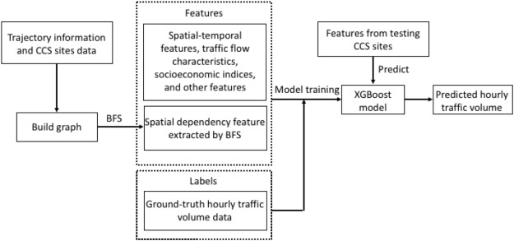

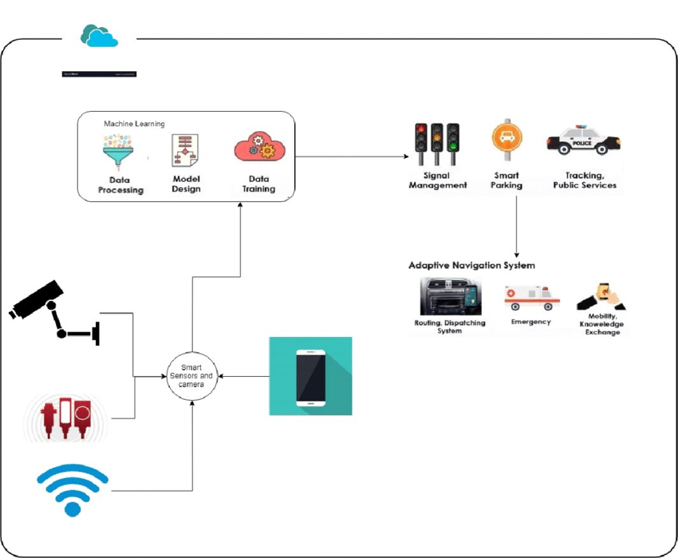

**User Stories**

Use the below template to list all the user stories for the product.

| **User Type** | **Functional Requirement (Epic)** | **User Story Number** | **User Story / Task** | **Acceptance criteria** | **Priority** | **Team Member** |
| --- | --- | --- | --- | --- | --- | --- |
| Customer (Web user) | Giving Input to model for Prediction | USN-1 | As a user I have to give the details to predict the volume of the data | The input should be gotten from the user | high | Subramanian R M |
| Customer Care Executive | Facing any issues | USN-2 | As a user when giving the input their error that has been facing | While getting input there may be an internet issue | Medium | Neha |
| Administrator | Managing Database | USN-3 | We have to store the Pervious stored data | Using MySQL we store the pervious collected to use in future | Medium | Seetharaman |